**ASSIGNMENT 4**

|  |  |
| --- | --- |
| Assignment Date | 19 September 2022 |
| Student Name | Nishanthini V |
| Student Roll Number | 820419104044 |
| Maximum Marks | 2 Marks |

1.Write a python program to test a given number is prime or not.

PROGRAM

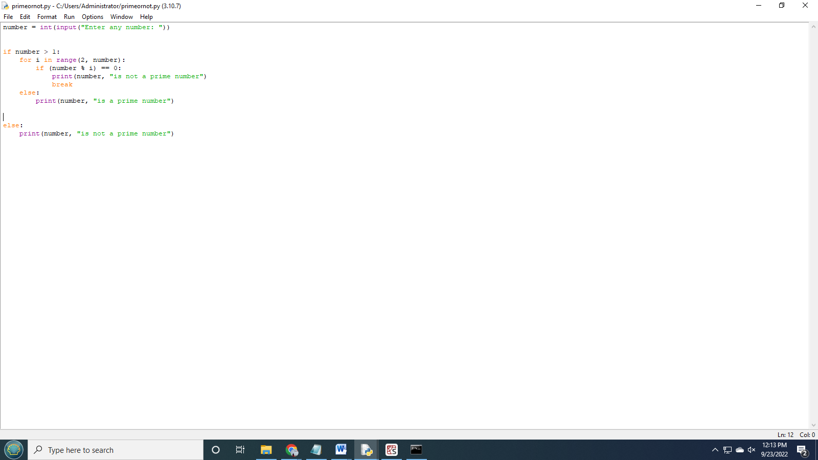

OUTPUT

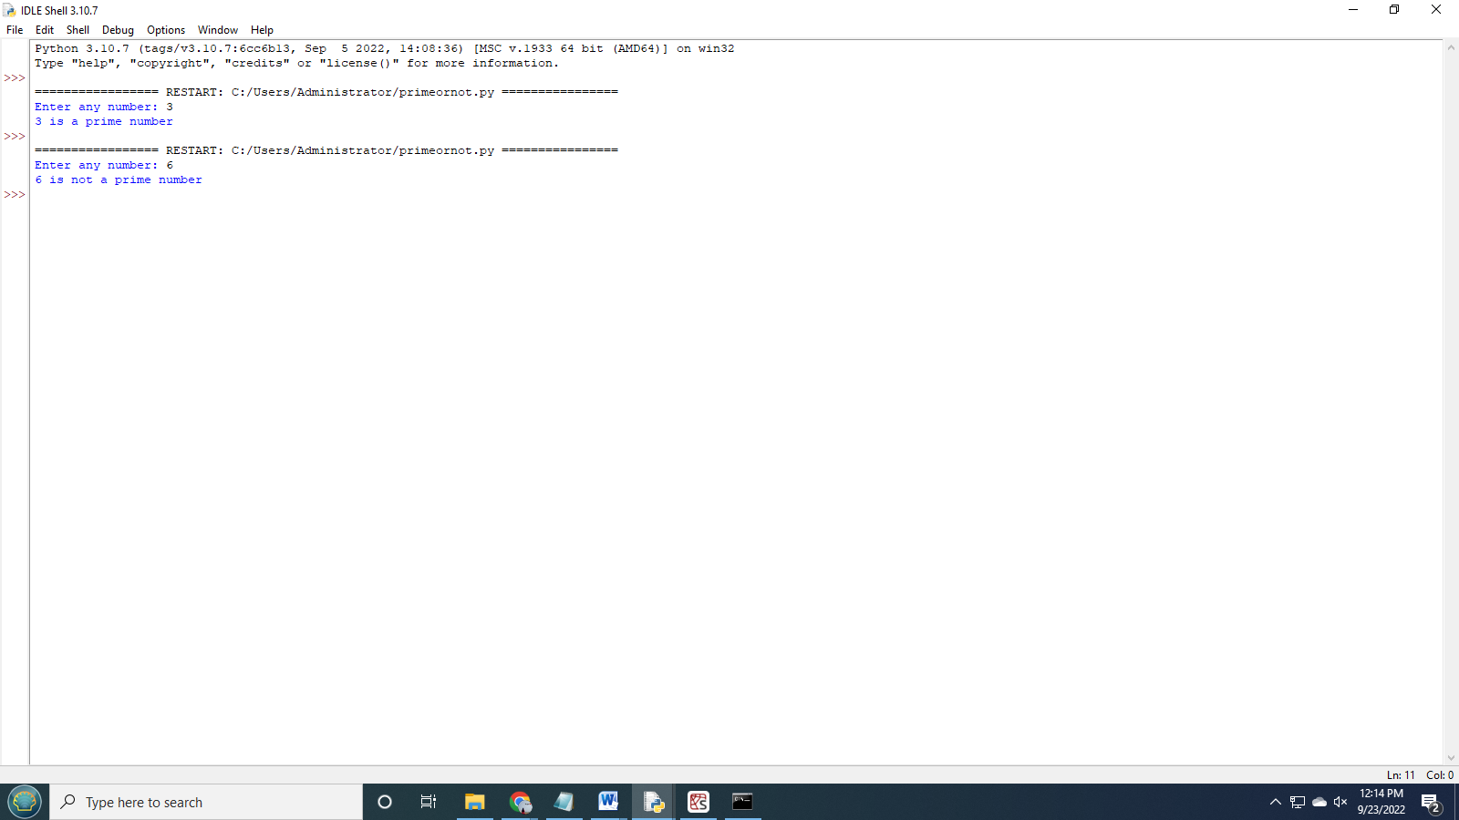

2.Write a program to generate odd numbers from m to n using while loop.

PROGRAM

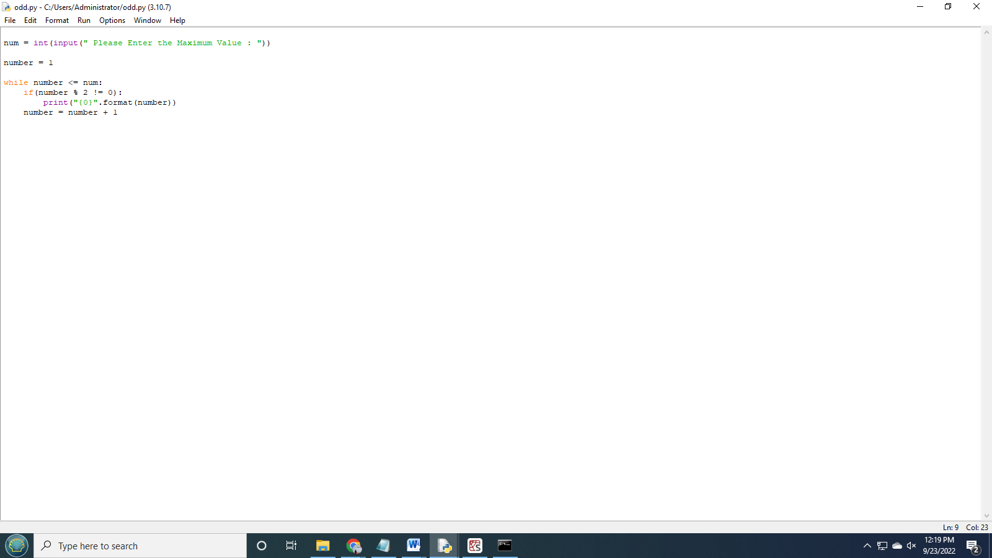

OUTPUT

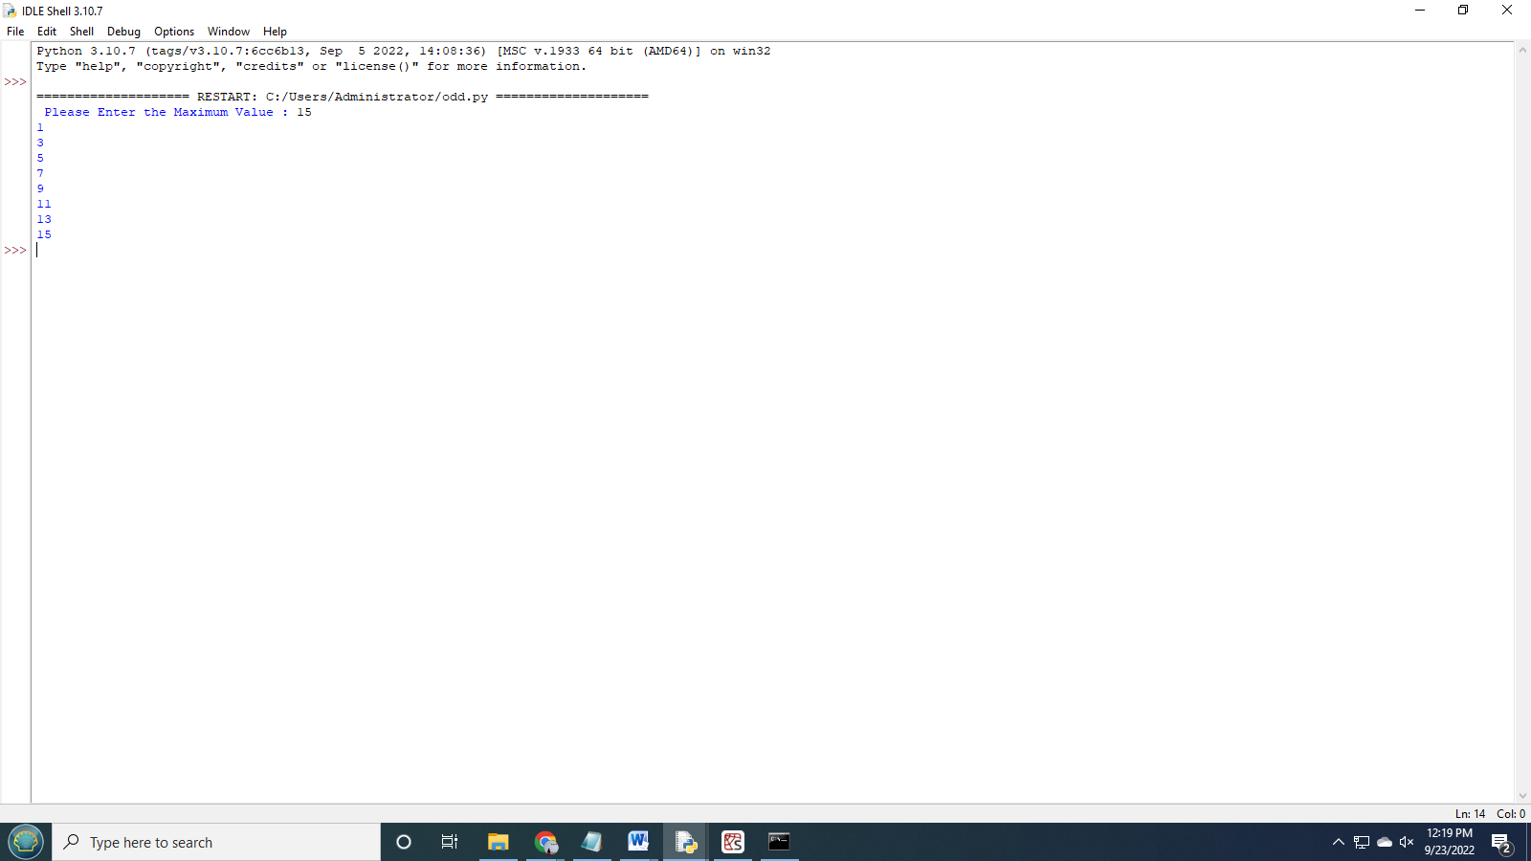

3.Write a python program to display prime number series upto given number.

PROGRAM

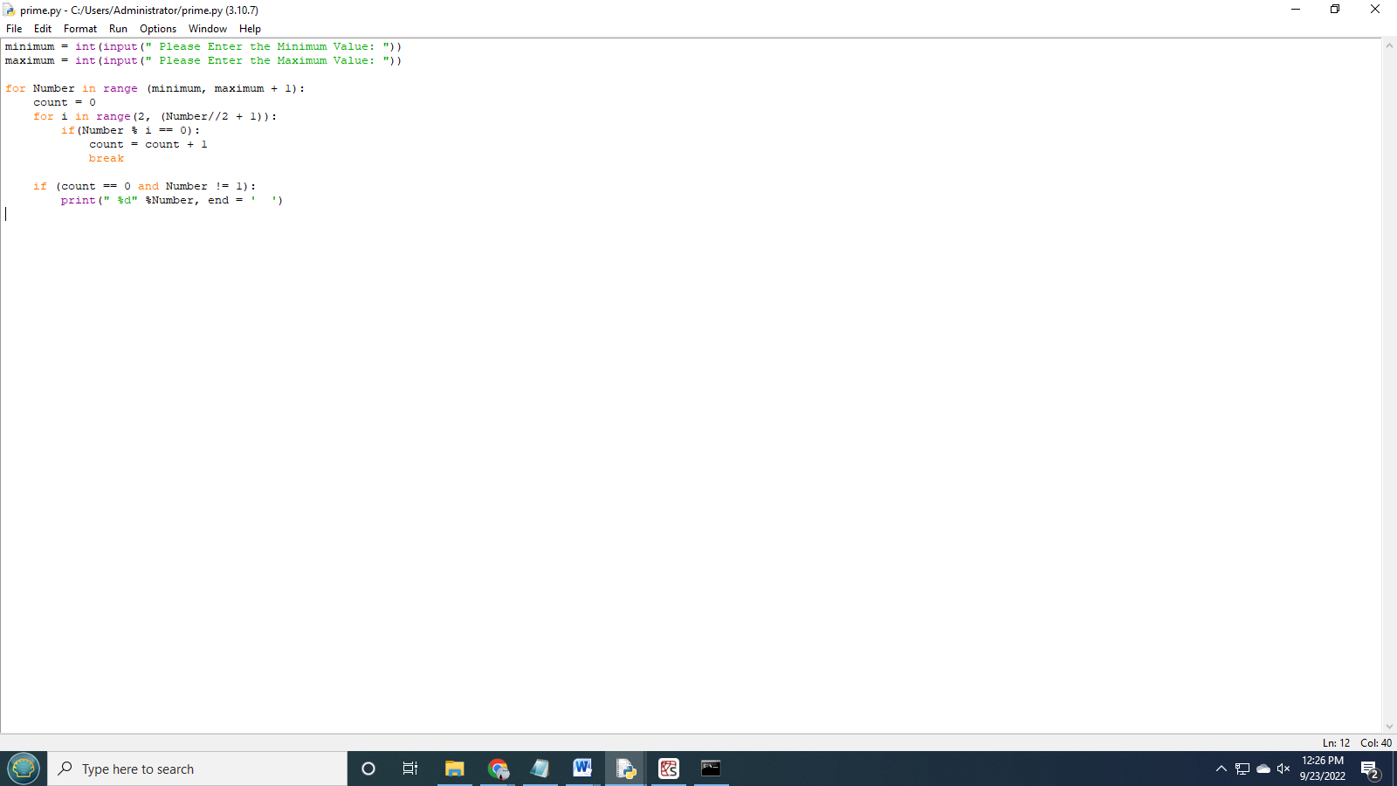

OUTPUT

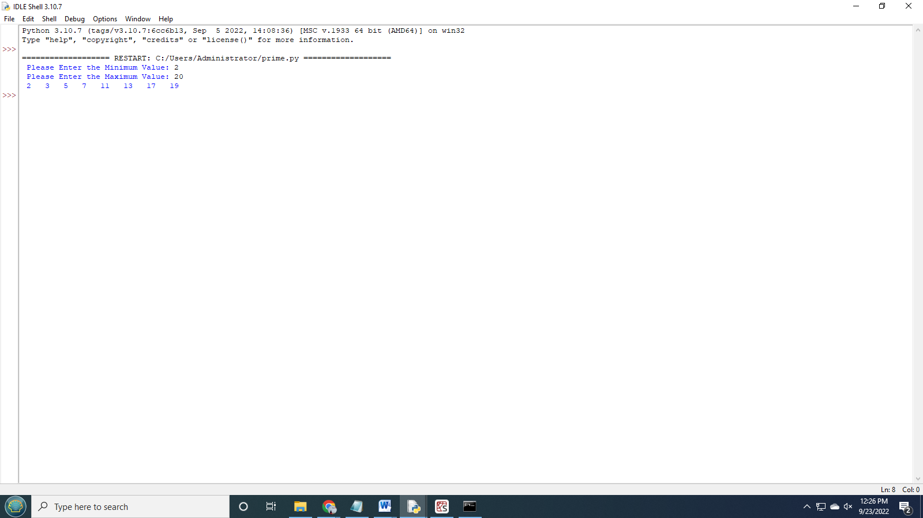

4.Write a python program to generate fibbonacci series.

PROGRAM

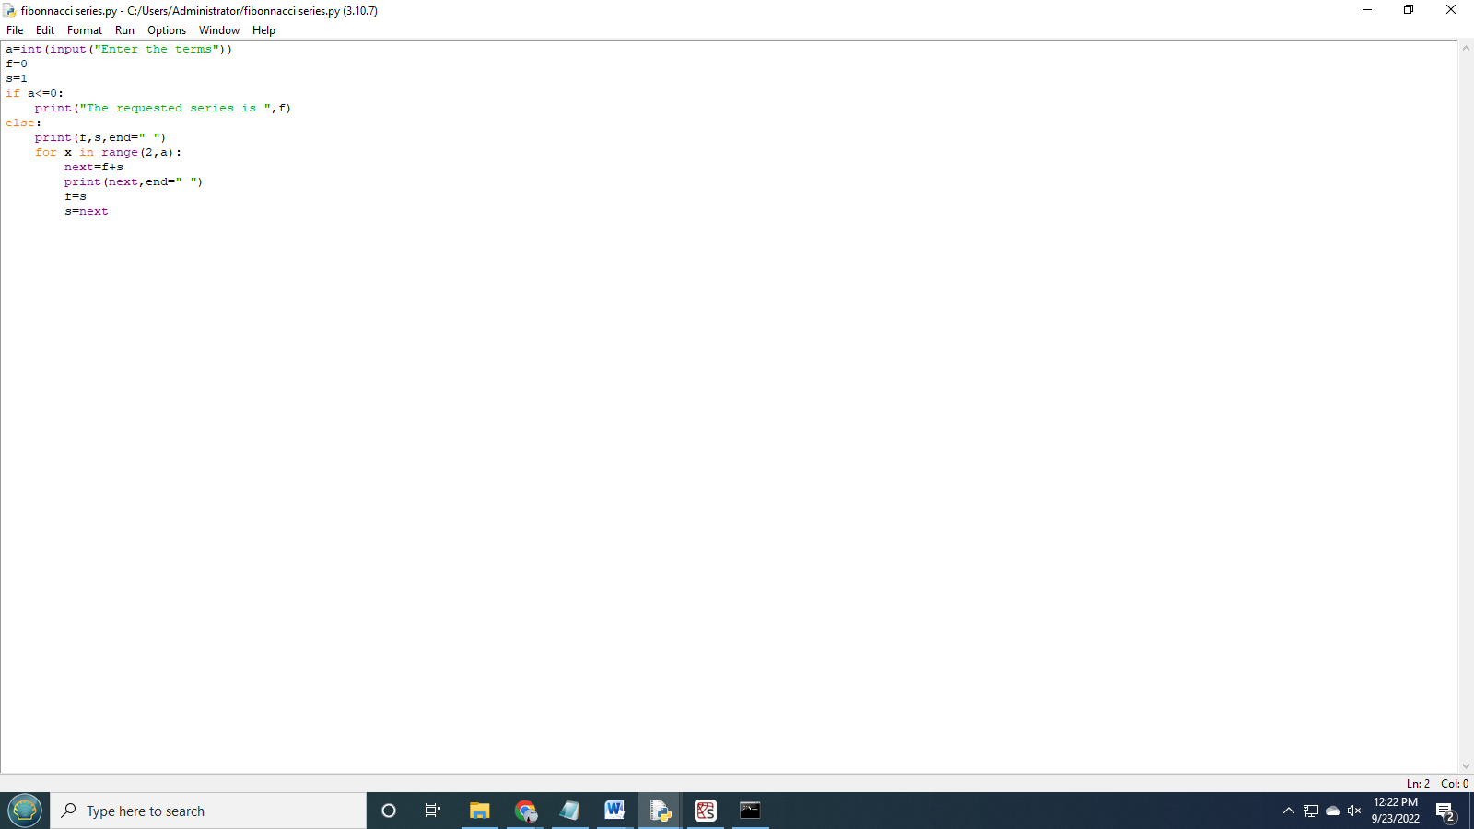

OUTPUT

